25th July 2019, third circular

IGCP-652 Meeting
21-27 August, 2019 Lanzhou

High-resolution Paleozoic geologic timescale

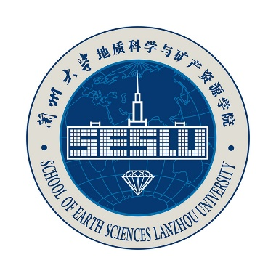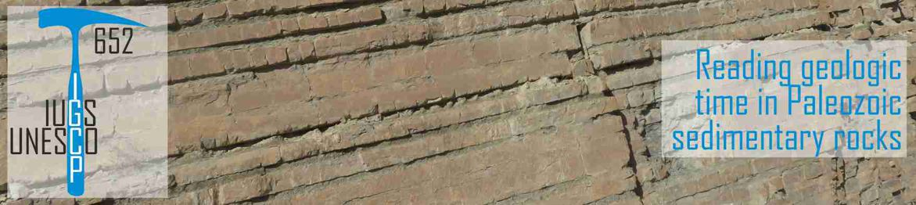

Sponsorship:
IGCP-652 Project Scientific committee
School of Earth Sciences, Lanzhou University
School of Earth Science and Resources, Chang'an University
School of Ocean Sciences, China University of Geosciences
Third Institute of Oceanography, State Oceanic Administration
Institute of Earth Environment, Chinese Academy of Sciences
National Science Foundation of China
K. C. Wong Education Foundation

Dear colleagues
IGCP 652 aims to improve the resolution of the Paleozoic time scale, which would in turn allow to get a better understanding of tectonic, climatic and biologic evolutions. In order to promote exchanges and attract more researchers in Paleozoic research, we are pleased to announce that the IGCP-652 meeting 2019 will be hosted in Lanzhou University, China, on 21 - 27 August 2019.

Meeting Agenda
21 - 22 August 2019: Pre-meeting workshop for spectral analysis. Lectures by Anne-Christine Da Silva from University of Liege and Xu Yao from Lanzhou University.
23 - 25 August 2019: Pre-meeting fieldtrip to look at cyclical Cambrian - Ordovician platform and slope deposits, as well as bentonites in the southwestern Ordos, China.
26 - 27 August 2019: Indoor meetings include oral presentations, poster sections, breakout group discussions and planning for future studies.

On Site Registration
For full program participants, registration desk will be in Tsuiying Hotel lobby in the afternoon of 20th August as well as the next morning in school hall at 11th floor of Guanyun building.
For participants only attend the indoor meeting, registration could be done in the 26th morning in the school hall at 11th floor of Guanyun building.

Payment of the participation fee
Full Program Participation: RMB Yuan 2800 or USA dollars 400, or RMB Yuan 2000 or USA dollars 300 for students (Post-doctors, PHD students, Master students).
– Accompanying persons: RMB Yuan 2000 or USA dollars 300.
These fees cover the registration, lunch and dinner in Lanzhou, as well as travel cost, two-night accommodation and 3 brief-meals a day during the field trip. Please notice that accommodation in Lanzhou is not included here.

Pre-meeting workshop: RMB Yuan 500 or USA dollars 75, or RMB Yuan 350 or USA dollars 50 for students (including coffee break and lunch).

Pre-meeting fieldtrip: RMB Yuan 1600 or USA dollars 240, or RMB Yuan 1400 or USA dollars 200 for students.
– Accompanying persons: RMB Yuan 1400 or USA dollars 240.
These fees will cover transport, accommodation (two nights) and food.

Indoor meeting: RMB Yuan 900 or USA dollars 150 for regular attendants, RMB Yuan 600 or USA dollars 120 for students (including coffee break, lunch and dinner).
– Accompanying persons: RMB Yuan 600 or USA dollars 120.

All Chinese attendants can choose to pay during on-site registration with cash or Alipay. Participants from abroad who do not have Alipay account need to pay with cash. Invoice will be collected during on-site registration.

Travel Grants
Participants who are admitted to get travel grant will receive it (in cash) at the conference closure.

Oral presentation
Each speaker will be allocated 15 minutes for his or her oral presentation, plus 5 minutes for questions. Speakers must prepare their talks as a Power Point presentation and copy the presentation to the USB memory (or driver). The organizer will provide PC laptop computer connected to the projector.

Poster presentation
Posters must be no larger than 0.9 m (width) × 1.20 m (height). Poster could be put on in the morning of 27th August in the school hall at 11th floor of Guanyun Building. Presentation and discussion will be held during 14:00-16:00 in 27th afternoon.

Language
The official language of the meeting will be English, and no translation facilities will be provided.

Access to Lanzhou
Participants will need to make their own travel arrangements.
Lanzhou international Airport (LHW) connects the city of Lanzhou with major hubs in China (Beijing, Shanghai, Nanjing, Xi’an, Chengdu, etc.) and takes 1 - 2.5 hours or so.
To and from the airport. It takes 40 minutes by metro or 1 hour by bus to the city center, and Lanzhou University (RMB Yuan 30). The metro departs airport every 30 minutes in the morning and every 60 minutes in the afternoon. The bus leaves the airport every 10 minutes between 07:00 and 02:00 next day. The taxi costs about RMB Yuan 160 and takes 40 to 50 minutes.
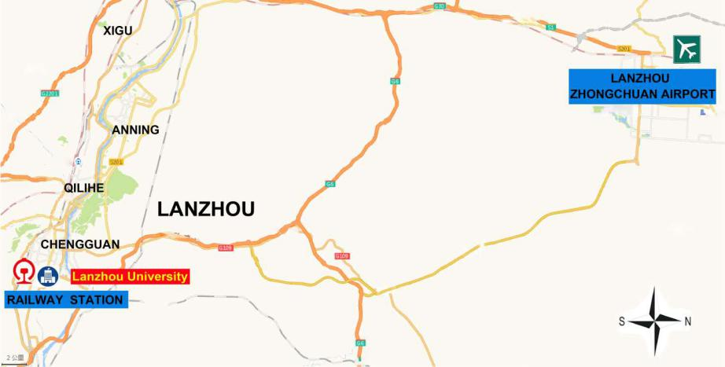
To and from the Lanzhou railway station. It takes 5 to 10 minutes by bus 1, 10, 110, 16 to Lanzhou University stop (RMB Yuan 30). Or 10 to 15 minute walk from Station to Lanzhou University.

To and from the Lanzhouxi railway station (high-speed rail). It takes 25-30 minutes by bus 1 to Lanzhou University stop (RMB Yuan 30), or 15 minutes by metro from Lanzhouxi station to Lanzhou University.

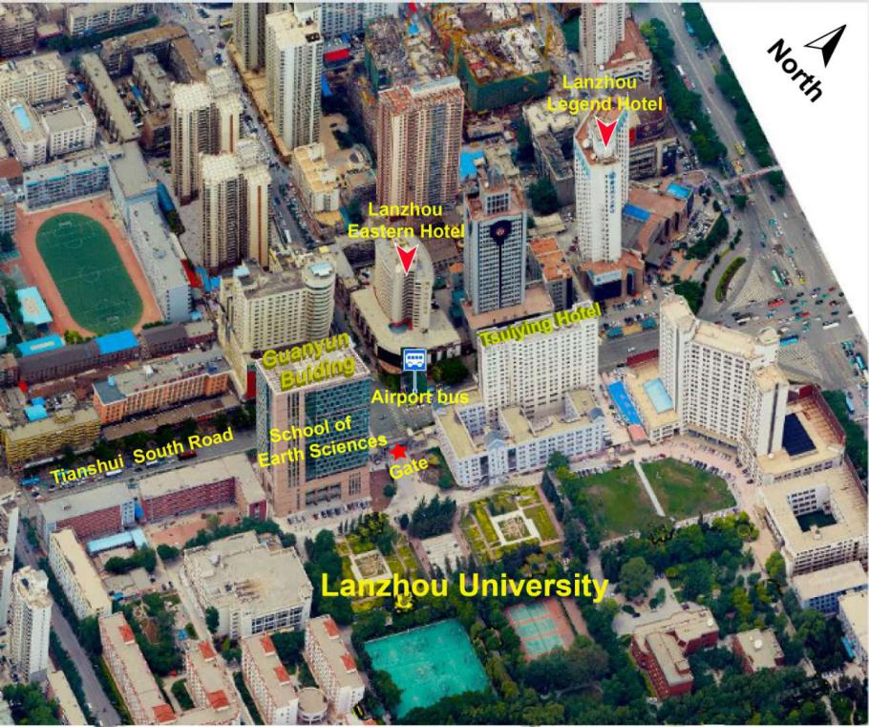

Pre-meeting field trip itinerary:
23rd August: take bus from Lanzhou to Pingliang, visit Ordovician stratigraphy on the four sections of Sidaogou, Yindong Guanzhuang and Taotongshan. Stay overnight in the Pingliang City.
24th August: visit 3 key sections of Cambrian, Ordovician and Carboniferous-Permian strata on Qishan-Linyou profiles; stay overnight in the Qishan City.
25th August: visit Ordovician stratigraphy on Jueshan section in Qishan, and return back to Lanzhou.
The weather there in late August might be humid and hot, and raincoat/umbrella may be useful. We mainly take bus, and there will be a few minutes walk in gravel path for Sidaogou sections, walking boots will be preferred in this section.

Accommodation in Lanzhou
We have booked Tsuiying Hotel for our conference participants. The cooperated rate is 280 Yuan RMB/night (including breakfast) for both single-bed room and double-bed room.

Food
We will provide Chinese style food. If you have food allergy or special requirements, please contact the meeting committee in advance.
Contacts:
Prof. Shuang Dai, Lanzhou University, Email: daisher@lzu.edu.cn,
Tel. and Fax. +86 931 8912307
Dr. Anne-Christine da Silva, University of Liege, Email: ac.dasilva@uliege.be
Dr. Ronghua Wang, Lanzhou University, Email: IGCP652@163.com

